30 free hours childcare

Please remember that if both parents are working, or if a single parent is taking home the equivalent of 16 hours @ minimum wage, you can claim 30 free hours childcare. Please log onto GOV.UK to make your claim, once you have your 30-hour code, please bring this to the office. The deadline for receiving funding next term is 31/12/2023. If you register after this date, you will not receive 30-hour funding for the January term.
Please remember you must resubmit every 3 months for your eligibility to 30 hours to continue, late submissions will result in fees being charged, these fees will be for the whole term until the next allocation.

Session Times
Please remember that Early drop off is 8.30am – 9.00am £2.50 anything prior to this will be charged at the breakfast club rate.
Children coming into session before 9.00am will be charged early drop off.
Breakfast Club 7:45am – 9.00am £5.00
Morning Session 9.00am – 11.30am £8.00
Lunchtime session 11.30pm – 12.30pm £3.50
Afternoon Session 12.30pm – 15.00pm £8.00

Naming items

Would you please name your child’s personal items they bring in from home, especially coats, lunchboxes and water bottles.

Pull ups if potty training
If your child is potty training, would you please place them in pull ups, as this makes it a lot more convenient for staff members. Staff will work with you when potty training your children.

Cutting foods in children’s lunchboxes
Please cut grapes, cherry tomatoes and other round foods in half lengthways, these foods are highlighted as choking hazards and therefore we need to ensure they are cut when placed in children’s lunchboxes.
We do not allow popcorn in lunchboxes

Parking at the rear of preschool
Please DO NOT park in the rear car park, there have been a couple of near misses with children as they walk behind reversing vehicles.
Also, if you park on Benyon grove and walk through the cut, please be aware that residents do live there and be respectful to their property.

We do have a large free car park at the front of the building which we would encourage you all to use.

Dogs in the playground
Please refrain from bringing dogs into the preschool garden/playground.

Keep us updated with contact details

Please ensure you keep us updated with changing details for your child, such as address, contact number, names of people to collect them etc.

Welcome to our new families and children, and welcome back to our old families and children
We hope you had a great summer break, and are ready for the year ahead. We are looking forward to working with you al during the year.

New staff
We have employed several new staff members to assist in the care and education of your children, we would like to welcome:

Anita Moualdi who will be working in the Confident Conker class and is an Early year’s educator practitioner.

Kirsty Haw who will be one of our lunchtime supervisors, and will work throughout the preschool.

Kirsty Sharpe who will be one of our lunchtime supervisors, and will work throughout the preschool.

Christina Amaddio who will be one of our lunchtime supervisors, and will work throughout the preschool.

Dates to Remember

- 04th September 2023 Return to preschool

- 12th September Primary school admission places open (for children entering reception class in September 2024)

- 27th September dress up day for Macmillan research £1.00 per child donation
Children receiving Disability Living Allowance
If your child is in receipt of DLA would you please inform the office, preschool may be able to get extra funding to support your child’s learning and interests.
We would just need to photocopy the front award page for evidence.

Dress up day to raise funds for Macmillan
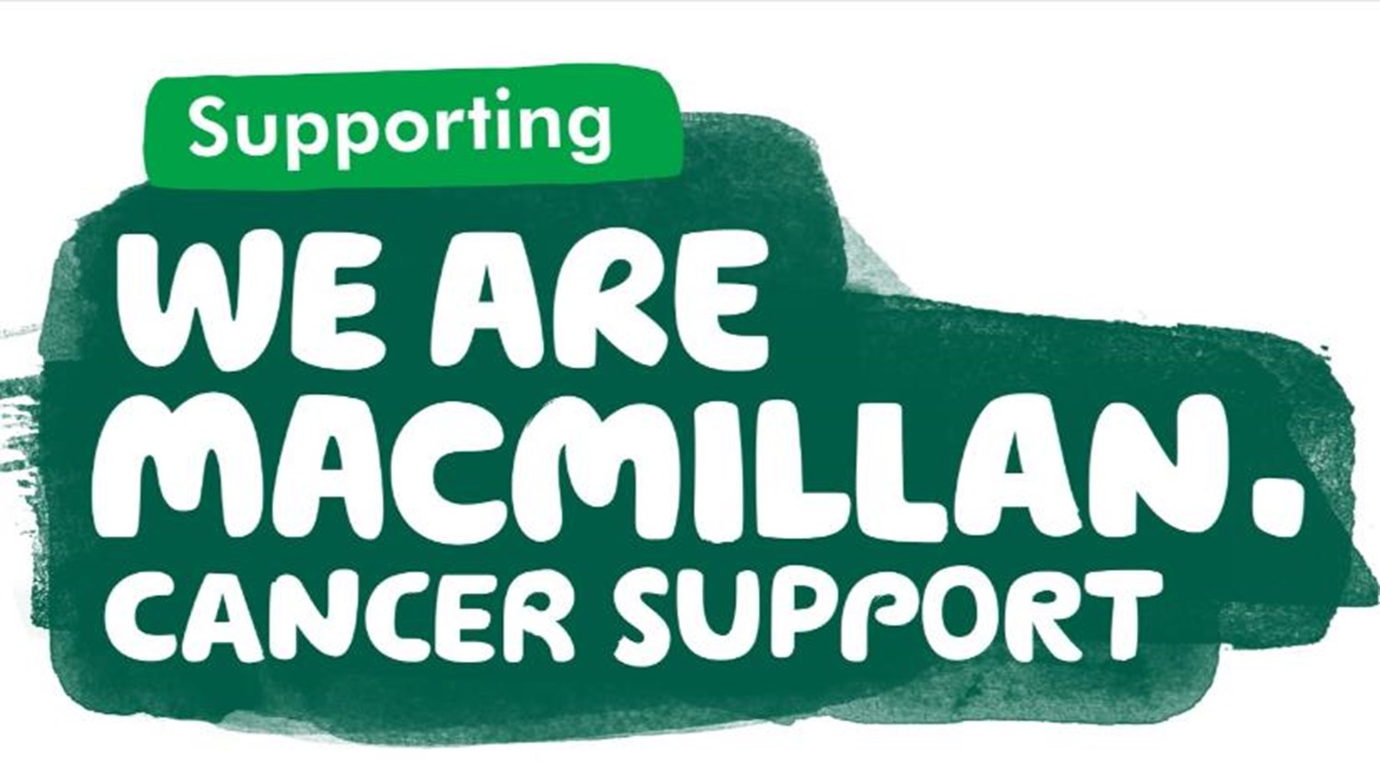

We will be holding a dress up day on Wednesday 27th September. There will be a £1.00 donation per child; all children may dress up in whatever they wish.
We will also have a tombola stall, teddy tombola and a cake raffle. All priced at £1.00 per go.

Please help to support this worthy cause.
All proceeds will be sent to Macmillan Trust

.

Nativity Tickets are now on sale priced at ed l
Xmas Raffle Tickets

